The Saddle Devil
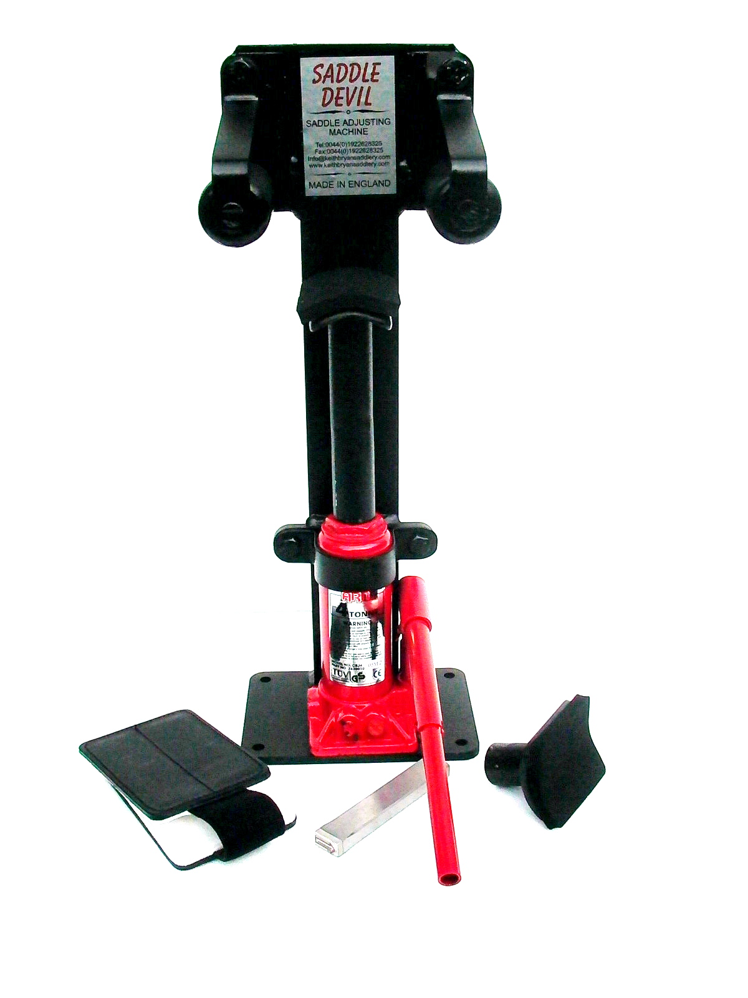
Saddle adjusting Machine
Made in England

The Saddle Devil
Saddle adjusting Machine
Terms and conditions

The Saddle Devil is designed to adjust fits on saddles in small amounts. From fit to fit i.e. Narrow to Regular, Regular to Wide, Wide to Extra Wide and in reverse order.
We do not recommend adjustments across fits i.e. Narrow to Wide
Regular to Extra Wide and in reverse order.
We accept no responsibility for any adjustments made by the operator
adjusting any saddles; we also accept no responsibility for any injuries to the operator or anyone attending the operator in adjusting saddles. We do not accept damage to any saddles that have been adjusted whether at time of adjustment or at any time thereafter. We accept no responsibility for any damage or injuries to the horse or the rider of saddles adjusted by the machine. We accept no responsibility for any advice given to anyone on adjustments or fitting of saddles with this machine.
Saddles that have been adjusted by this product shall be stamped on the
saddle to show which way the saddle was adjusted. It is the operator’s
responsibility to determine how many times a saddle can be adjusted or whether a saddle can be adjusted at all.
The product is not to be used on any self-adjusting saddles. Or saddles with no steel head plate
The hydraulic ram has its own instructions, read them before operating
the machine.
The Saddle Devil machine shall only be operated by Saddlery trade
persons and not to be used to replace reflocking of saddles.

www.saddledevil.com

THE SADDLE DEVIL

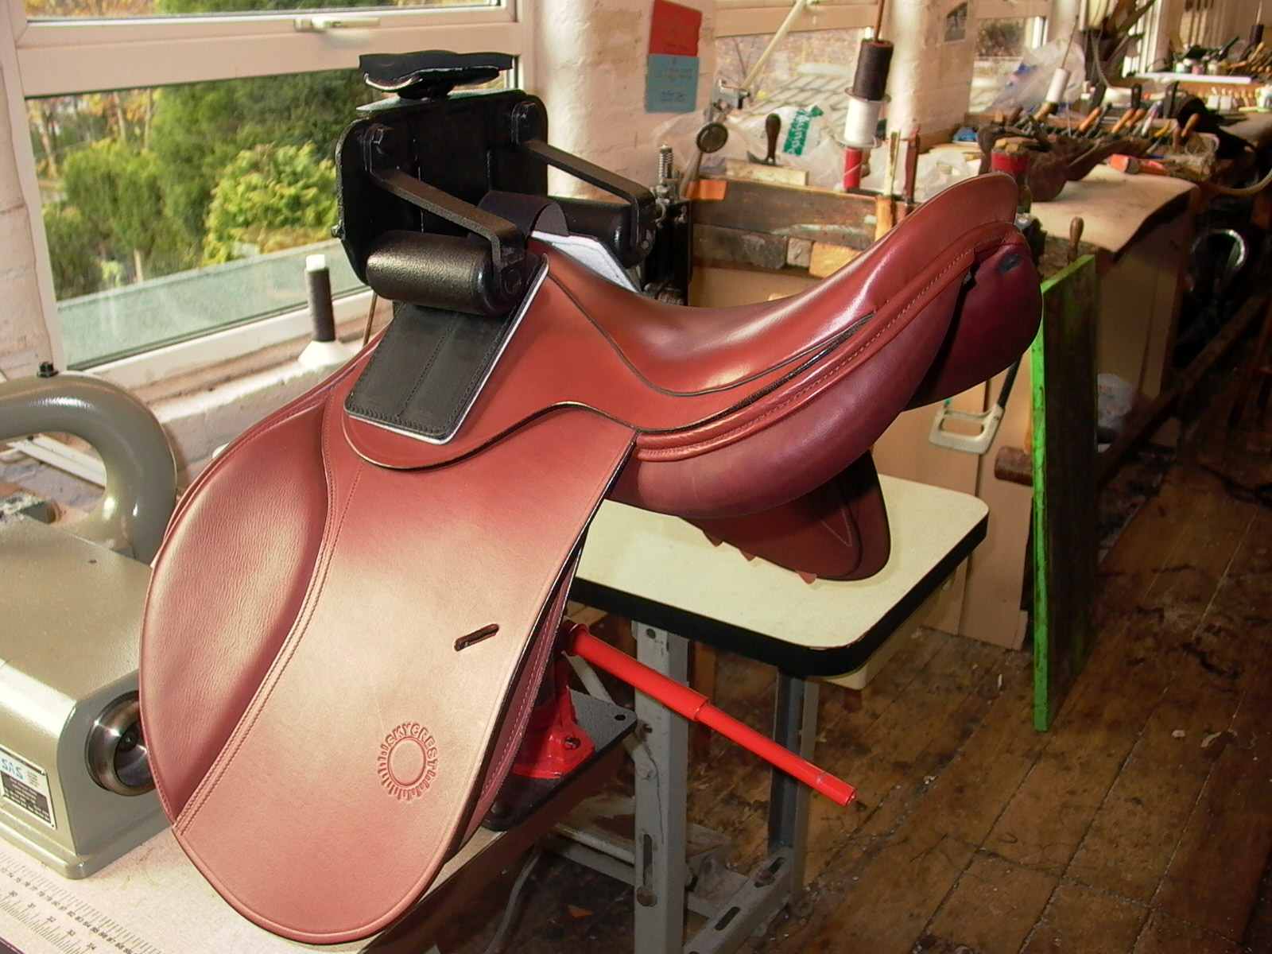

To Narrow Saddles

To narrow a saddle, place the long convex ram onto the hydraulic jack. Push down fully then tighten the valve on the jack. Rest the underside of the pommel onto the pad of the ram; making sure that the saddle is square. Place the protecting pads onto the top of the saddle. Pump the handle of the jack; this may take several repartitions to start any movement. When the saddle with the protectors reach the underside of the rollers, pull the protectors upwards by the elastic strip, so that one third is in contact on both sides, of the rollers. Look at the above image to see where the pads are in relation to the rollers. When satisfied that everything is square. Pump the handle on the jack, the pressure will increase and narrow the saddle. You can look on the other side of the machine to see how much the saddle has narrowed. When the desired width has been reached unscrew the release valve on the jack by half or so turns. Take out the saddle and stamp the sweat flap with the arrows pointing inwards.

THE SADDLE DEVIL

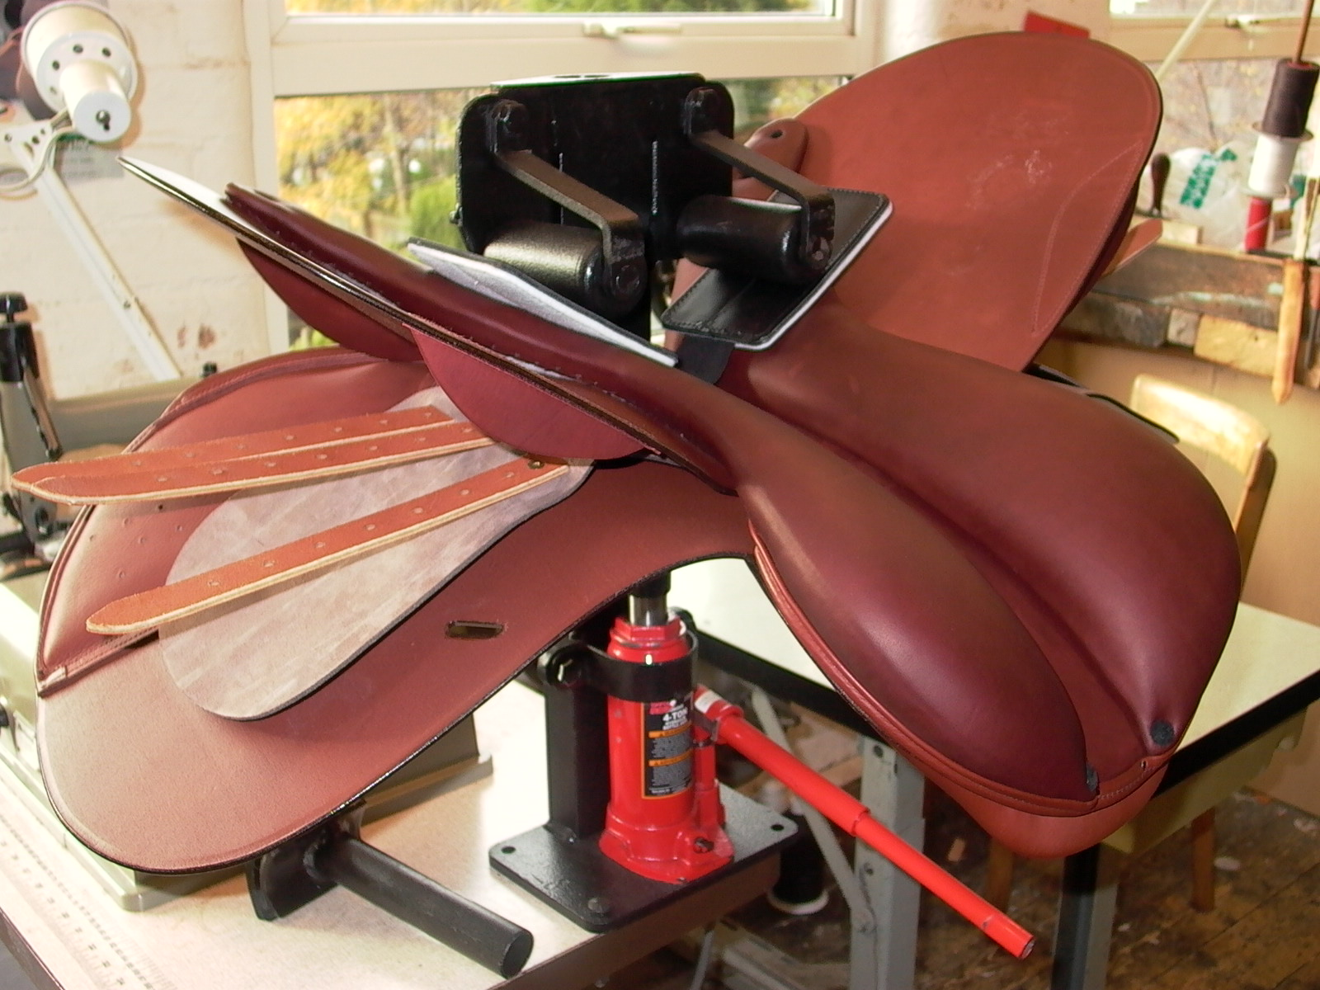

To Widen Saddles

To widen a saddle, place the shorter concaved ram onto the hydraulic jack. Push down fully then tighten the valve on the jack. Rest the pommel of the saddle onto the pad, making sure that it is square. Pump the handle on the jack so that there is a small gap in-between the top rollers and the under side of the saddle. Now push the protecting pads into this gap. Look at the above image to see where the pads position is in relation to the rollers. When satisfied everything is square Carefully pump the handle on the jack, the pressure will increase and widen the saddle. You can look on the other side of the machine to see how much the saddle has widened out. When the desired width has been reached unscrew the release valve on the jack by half or so turns. Take out the saddle and stamp the sweat flap with the arrows pointing outwards.

